Criteria D Analysis for NCRA Comoros
Swaleh Aboud
2024-12-05
Table of contents

1. About the Document

2. Data and Folders
The working directory for this project is currently hosted in a private repository to facilitate collaboration with an external contributor, Franzinho Smith. Once significant progress has been achieved, the project will be transitioned to the Organizational repository for broader access. The dataset utilized for this analysis is available and can be accessed in the CORDIO GitHub repository at the following path: -Juvenile-ManuscriptNCRA_codeD.

3. Datasets

4. Evaluate Criteria D

4.1 Hard coral
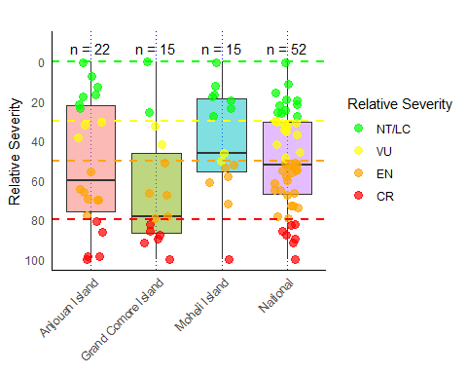
Fig. 1; Relative severity for Hard coral by ecoregion, with points color-coded according to IUCN RLE status (NT/LC, VU, EN, CR). The number of data points for each ecoregion is indicated by n
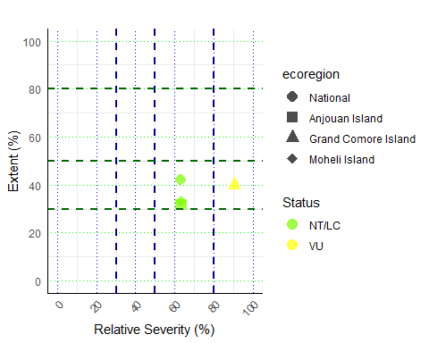
Fig. 2; Criteria D results for Hard coral included Relative severity versus extent by ecoregion, color-coded by IUCN RLE status. Dashed lines represent threshold values for severity and extent (30%, 50%, 80%).

4.2 Macroalgae Coral Ratio (MaCoR)
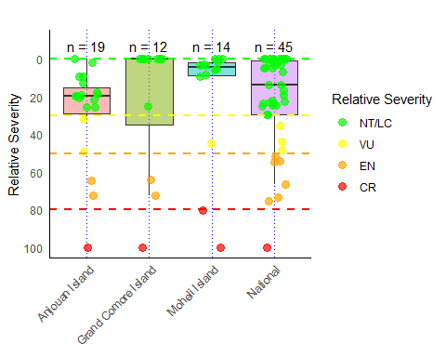
Fig. 1; Relative severity for MaCoR by ecoregion, with points color-coded according to IUCN RLE status (NT/LC, VU, EN, CR). The number of data points for each ecoregion is indicated by n
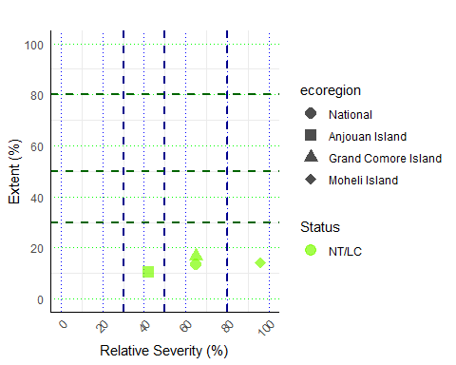
Fig. 2; Criteria D results for MaCor included Relative severity versus extent by ecoregion, color-coded by IUCN RLE status. Dashed lines represent threshold values for severity and extent (30%, 50%, 80%).

